GYN GUIDELINES & PROTOCOLS
-Readers
- Communication plan with readers
- GYN Exam Types
- Scanning protocol
- 3D imaging- when to perform, when to bill. Tips/tricks
- Fibroid mapping; what fibroids to document and how many
- O-RADS
- Polycystic Ovarian Morphology – Diagnostic criteria
- ASRM Uterine anomaly guidelines
- Documenting C-Section Niche
- Adenomyosis
- SIS: tray set up; consent form; who receives a UPT; how to bill
- US guided procedures; consent form; supplies needed
- Incidental Findings- documentation, reporting
-Common Scenario Workflow:
- What is this Adnexal Finding in a Pregnant Patient Who Has an IUP?
- Is It an OB or GYN Ultrasound? Patient Presents with +HCG with no IUP
- Evaluate for RPOC (known prior pregnancy loss or status post-delivery)
- OB vs GYN- how to change EPIC order, change VP requested procedure, reader

GYN READERS:
Angie Kondrat
Brandi Vasquez
Brooke Andrews
Dafna Lohr
Damon Warhus
Jen Lin
Lisa Johnson
Maryanne Garvie-Loveland
Michele Quinn
Stephanie Lee

(USC EXTERNAL PHONE #503-296-7416)

GYN Ultrasound Finding Communication Plan
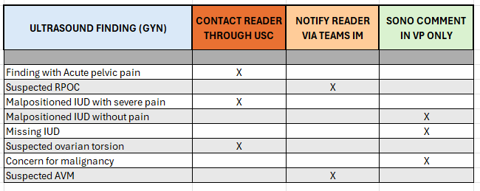

GYN Exam Types
- US Pelvis Complete w/ Doppler if Indicated (CPT 76856)- Complete assessment of pelvis
  - Transabdominal stand alone, or
  - Transvaginal (CPT 76830) in addition to transabdominal
- US Transvaginal Pelvic Ultrasound (CPT 76830)
- US Limited or Follow Up (76857)
- US Hysterosonography (76831)
- GYN procedure ultrasound guidance (76998)
  - IUD insertion/removal
  - EMB (endometrial biopsy)
Scanning Protocol
US Pelvic Complete- comprehensive assessment; complete transabdominal approach, +/- transvaginal approach (CPT 76856, +/- 76830)
**all findings: measure in 3 orthogonal planes, with and without color Doppler, 3D as indicated
Sag ML Ut (L x H x CVX measurements)
Sag Ut Rt x 2
Sag Ut Lt x 2
Sag Endo (measurement)
Sag Endo w/ color
Sag Ut Rt-Lt Cine Sweep
Sag Cvx/Cul de Sac
Trv Cvx/Cul de Sac
Trv LUS
Trv Ut Body (width measurement)
Trv Ut Fundus
Trv Ut Inf-Supr Cine Sweep
Sag/Trv Right adnexa
Right Ovary (L x W x H measurements)
Right Ovary 2D- cine sweep
Right Ovary color Doppler- static
Right Ovary color Doppler- cine sweep
Sag/Trv Left adnexa
Left Ovary (L x W x H measurements)
Left Ovary 2D- cine sweep
Left Ovary color Doppler- static
Left t Ovary color Doppler- cine sweep

Transvaginal US - non-obstetrical (CPT 76830); complete transvaginal assessment of female pelvis -see scanning protocol above

Limited or Follow Up- non-obstetrical (CPT 76857)- focusing on specific structures
***patient must have a comprehensive pelvic US within 6 months***

- Follicular studies
  - Perform a focused transvaginal assessment of pelvic organs
  - Measure the AP dimension of the endometrium obtained from a Sagittal view. Include the hyperechoic/hyperechoic endo walls; Exclude intracavitary fluid and adjacent myometrium
  - Early Follicular Stage (approximately day 0-6 of cycle):
    - Antral follicle count ≤9 mm (how many in total)
    - Measure follicles of ≥10mm
  - Mid & Late Follicular Stage (approximately day 7-13 of cycle)
    - Follicle count ≥11mm (how many in total)
    - Minimum of the 3 largest follicles in each ovary measured in at least 2 perpendicular dimensions and the MEAN recorded.
*antral follicles measure 2-9 mm in diameter
*normal antral follicle count (AFC) 12-24
*Calculation- total number of follicles from both ovaries is added together to produce the final AFC

- REI endo measurement standalone –
  - Perform a focused transvaginal assessment of the endometrium
  - Measure the AP dimension of the endometrium obtained from a Sagittal view. Include the hyperechoic/hyperechoic endo walls; Exclude intracavitary fluid and adjacent myometrium

Saline Infused Sonohysterogram (SIS) – (CPT 76831)
***patient must have a comprehensive pelvic US within 6 months***
Pre-procedural documentation:
Transvaginal approach
- image the endometrium with 2D and color Doppler in 2 orthogonal planes to demonstrate the appearance of the endometrial cavity for the provider to determine if a SIS procedure is necessary.

Procedural documentation when fluid is instilled:
Transvaginal approach
- image the uterus/endometrium with cine clips in 2 orthogonal planes
-measure anterior and posterior endometrial thicknesses (can be obtained post process)
-document pathology in 2 orthogonal planes, with & without color Doppler, measure pathology.
3D: Provider may request a 3D image.

GYN US Procedure Guidance (CPT 76998) – IUD insertion/removal, EMB (endometrial biopsy)
- Pre-procedural documentation:
Transabdominal approach - static images
-Sag Ut – document position of uterus
-Trv Ut
-Endometrial measurement/presence of IUD
- Live procedural documentation
Transabdominal approach:
-Sag UT guidance during instrumentation- document a static image
* IUD removal- obtain cine clip of IUD being removed
* IUD insertion- obtain cine clip of IUD insertion. Document position & placement of IUD in 2 orthogonal planes demonstrating appropriate IUD placement.
*Transvaginal may be performed if necessary for confirmation of IUD placement; 3D may also be performed

3D Imaging (CPT 76376)
When to perform:
- *if 3D may provide additional diagnostic information
  - When assessing IUD position
  - When assessing for a uterine anomaly
  - **other gyn findings
  - Skill building
When to bill (CPT 76377)
- When assessing IUD with a complication (pain, abnormal bleeding, lost strings)
- When assessing a newly suspected uterine anomaly
- When the rendered 3D image provides additional diagnostic information

Fibroid Mapping
When to document:
- When performing a comprehensive pelvic ultrasound,
- Targeted limited ultrasound to assess fibroid size/growth
- During obstetrical ultrasounds
Which fibroids to document:
- Measure the 3 largest OR most clinically relevant in location (ie: submucosal)
- Enter size, description, and location in the viewpoint report
How to document:
- Obtain 3 measurements in 2-orthogonal planes
- Obtain color Doppler
- Transvaginal imaging is preferable to provide the highest clarity of fibroid borders. But, for large fibroids transabdominal imaging may provide the clearest borders overall.

Classification of Fibroids:
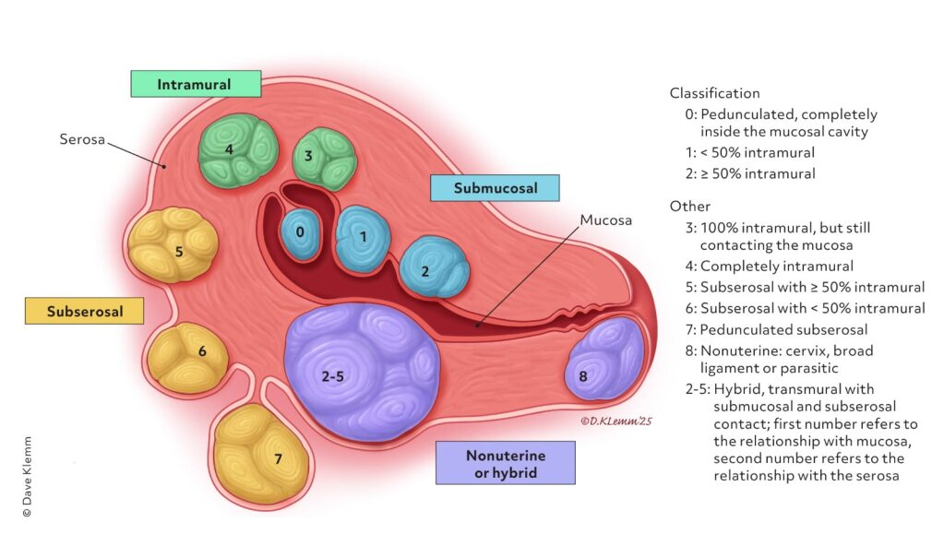

O-RADS Cyst Guidelines
Normal Ovary (O-RADS 1)
- No lesion
- Physiologic cyst
  - Follicle
  - Corpus Luteum
Classic Benign Lesions (< 10cm = O-RADS 2; >10 cm = O-RADS 3)
*For atypical features, use other lexicon descriptors
- Extraovarian: Typical Paraovarian Cyst, Typical Peritoneal Inclusion Cyst, Typical Hydrosalpinx
- Ovarian: Typical Hemorrhagic Cyst, Typical Dermoid Cyst, Typical Endometrioma
Other Lesions (O-RADS 2 to O-RADS 5)
- Cystic Lesion: +/- internal echoes; +/- incomplete septations
- Solid/Solid- appearing lesion: ≥ 80% solid
*refer to O-RADS Assessment Categories for detailed description & final O-RADS scoring
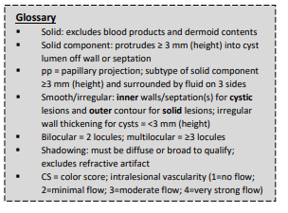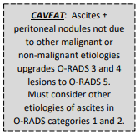

O-RADS Assessment Categories
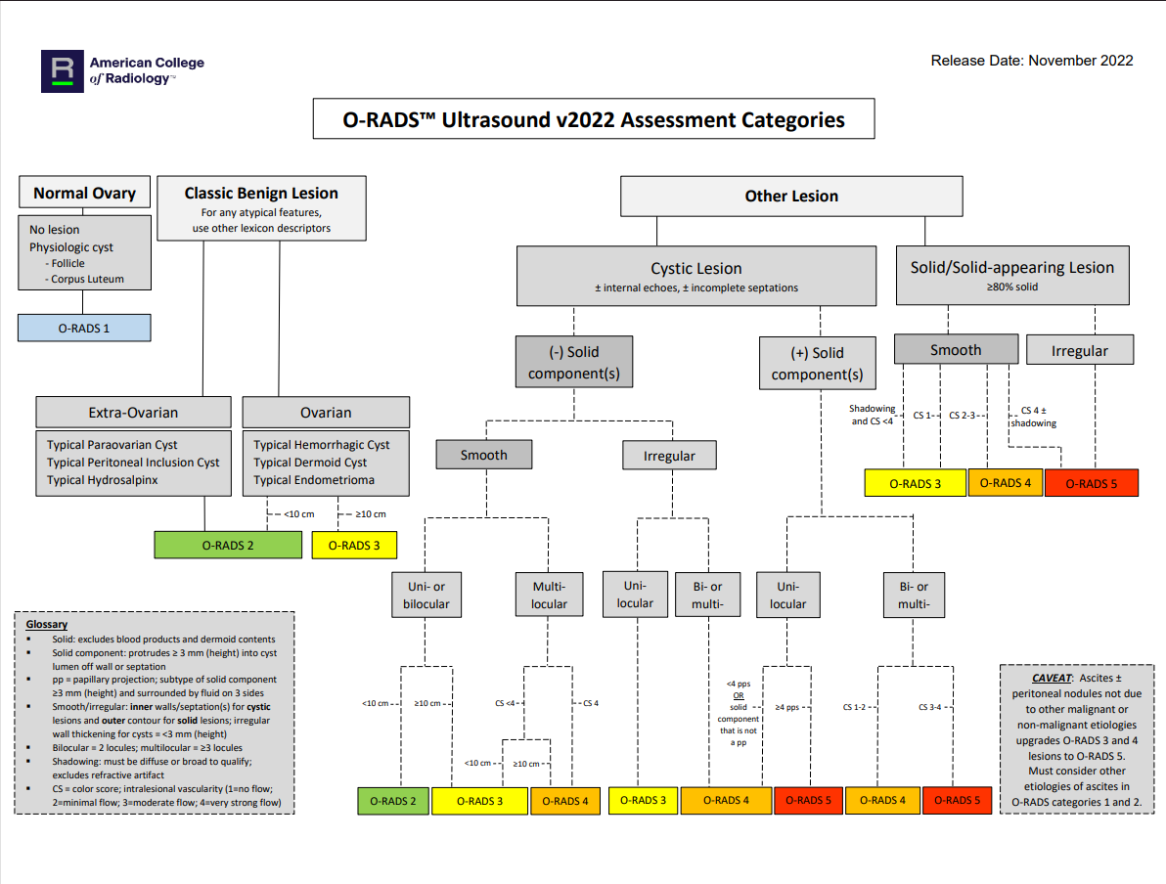

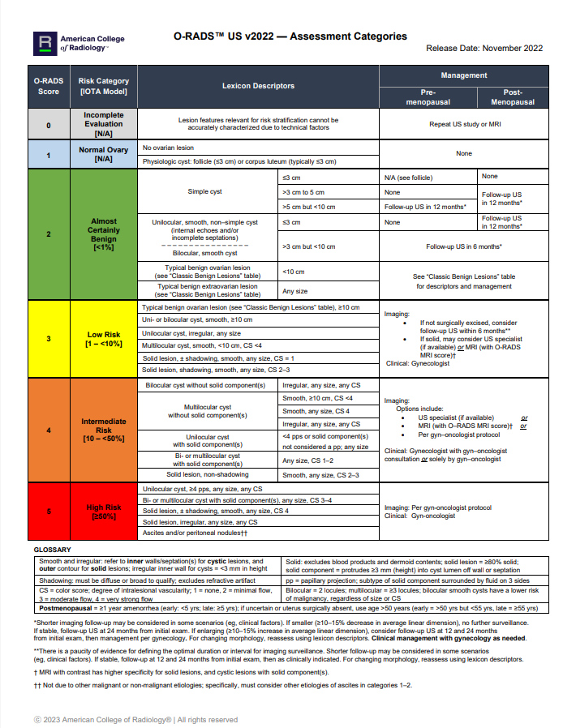

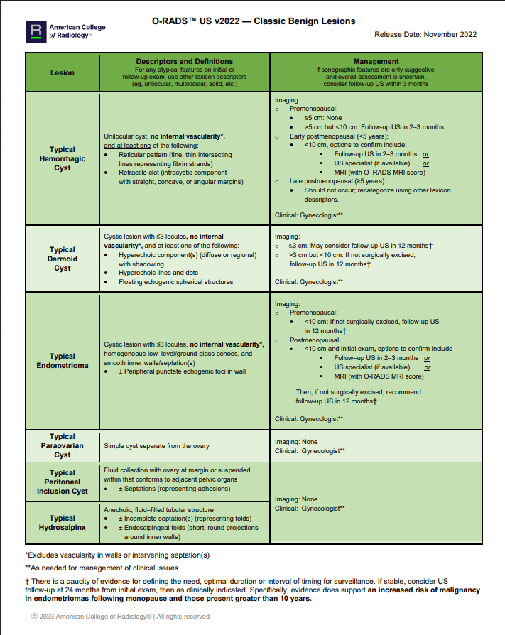

ACR Lexicon Categories, Terms, Definitions
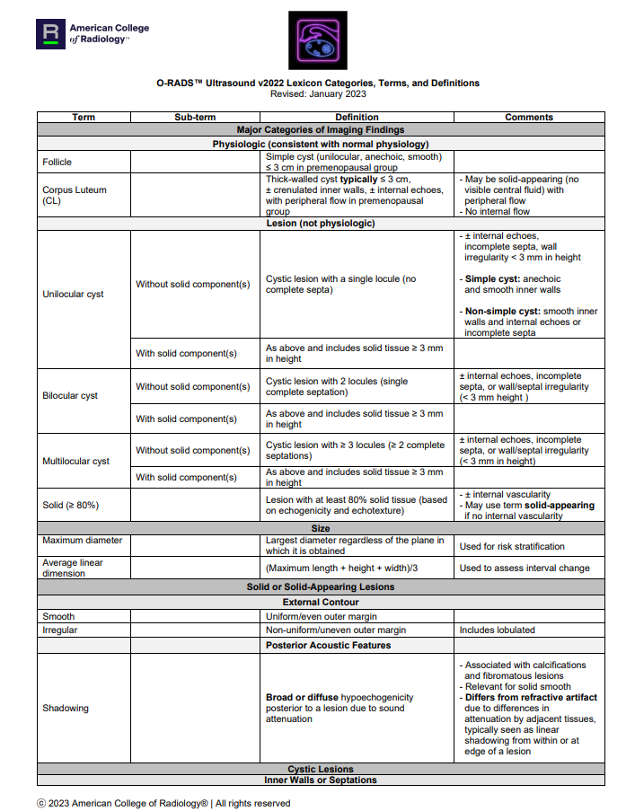
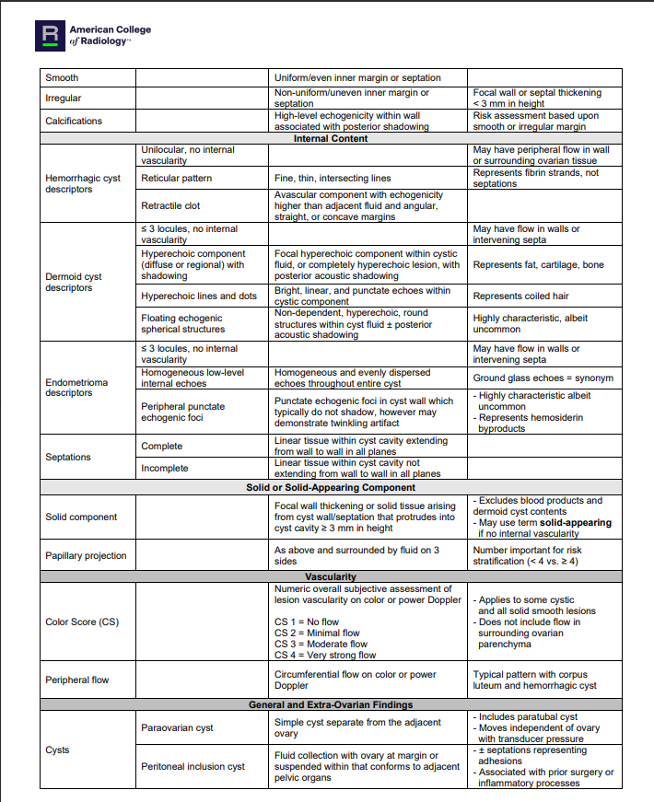

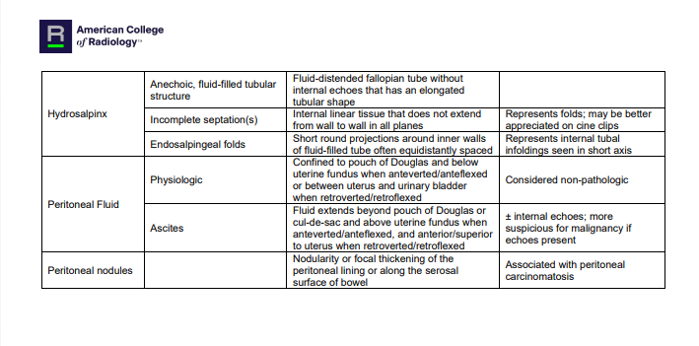

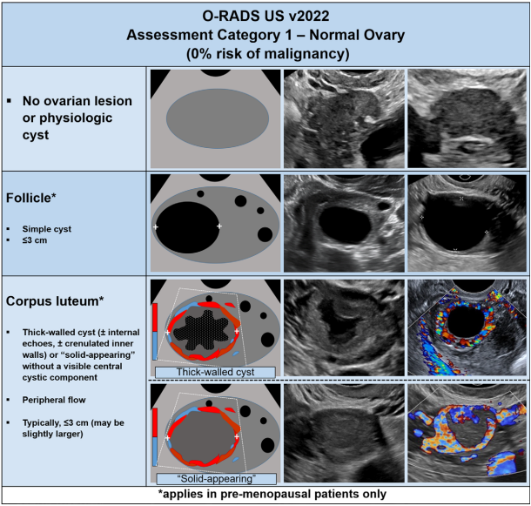
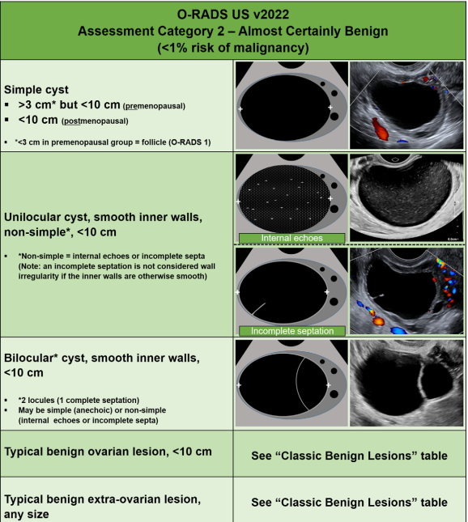
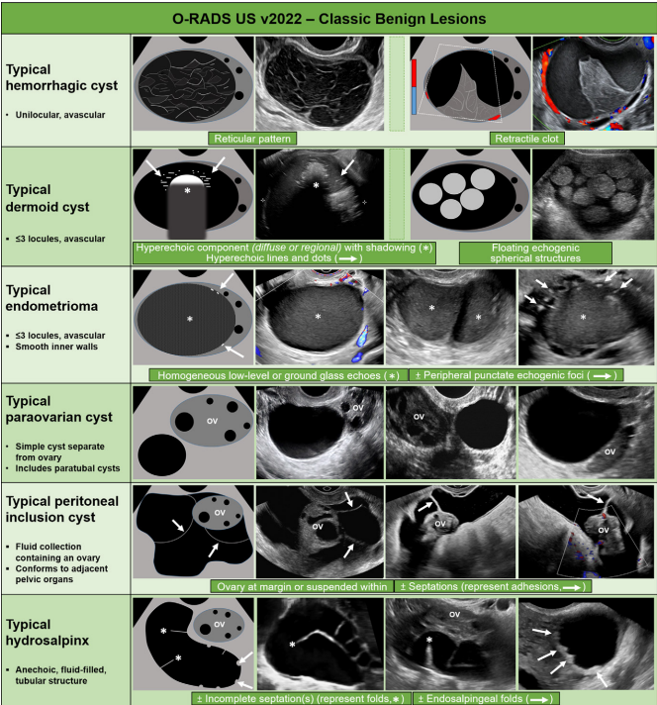

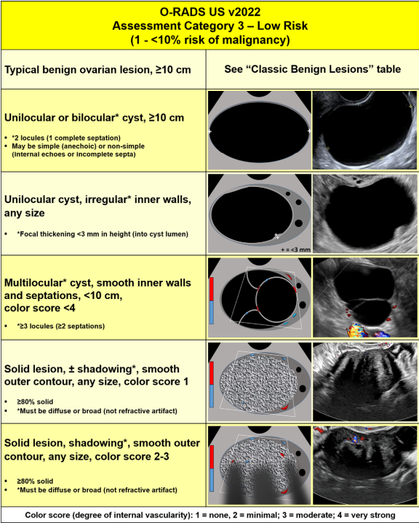

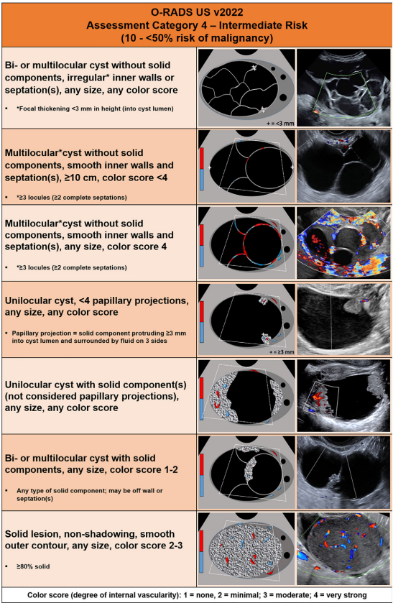
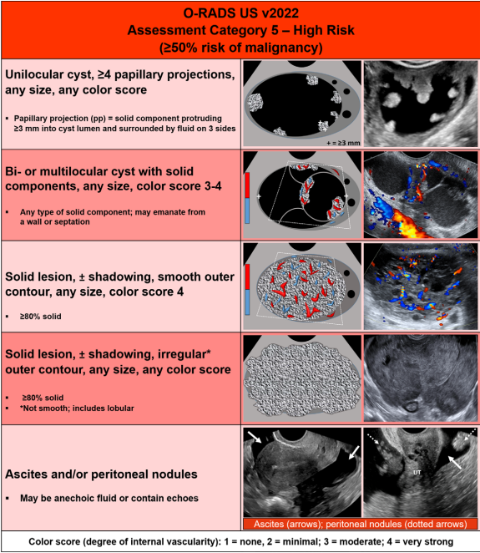
Polycystic Ovarian Morphology- Diagnostic Criteria
- 10 or more follicles seen within a single cross section of at least one ovary OR
20+ follicles in at least one ovary
- Follicle size 2-9 mm
- Ovarian volume ≥ 10 ml; *not including corpus luteum or other ovarian cyst
- PCO morphology in a single ovary meets diagnostic criteria
- *Diagnostic criteria does not apply to adolescent patients - age 10-19 years of age
Uterine Anomalies- ASRM (ASRM müllerian anomalies classiﬁcation 2021 | American Society for Reproductive Medicine | ASRM)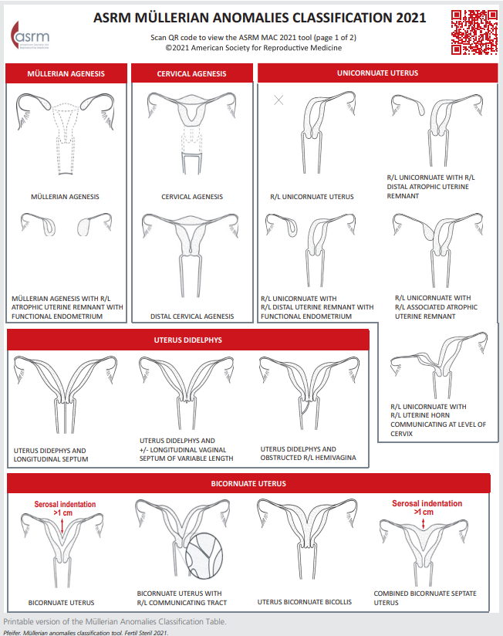
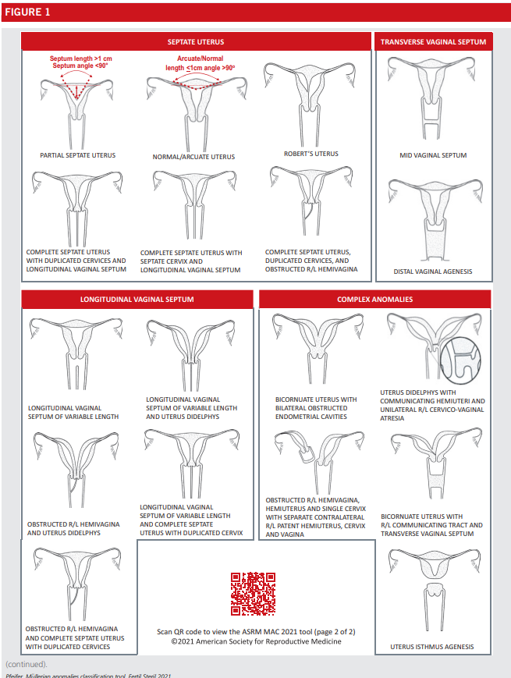
Differentiating Uterine Anomalies Sonographically:
- Didelphys:
  - 2 cervices/2 endometrial cavities/2 unicornuate uteri
  - Fundal indentation > 1 cm
- Bicornuate
  - Single cervix/2 endometrial cavities (separation can extend to internal os)
  - Concave fundus with fundal endometrial cleft > 1 cm
  - Increased inter-cornual distance > 4 cm
  - Intervening septum echogenicity similar to myometrium
- Septate
  - Convex fundal contour (normal external contour)
  - Inter-cornual distance > 2 cm
  - Septum composed of muscle or fibrous tissue
- Arcuate
  - Convex fundal contour (normal external contour)
  - Fundal endometrial cleft < 1 cm.

How to measure inter-cornual distance & endometrial cleft
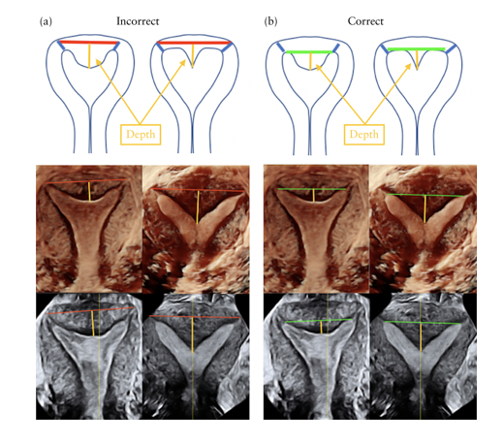
*tip: obtain 3D image from a transverse view to increase the field of view when the uterine horns are anatomically far apart.

Documenting C-Section Niche/Isthmocele
- Document & measure the myometrial scar defect in 2 orthogonal planes (#’s 1-3 in illustration below)
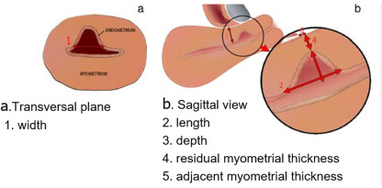
Adenomyosis Descriptors:
- Heterogeneous myometrium
- Globular uterus
- Asymmetrical myometrial thickening
- Subendometrial cysts
- Hyperechoic islands
- Fan-shaped shadowing
- Echogenic subendometrial lines and buds
- Translesional vascularity
- Irregular junctional zone
- Interupted junctional zone

Heterogeneous/fan-shape shadowing Hyperechoic island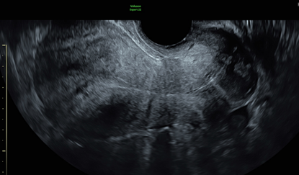 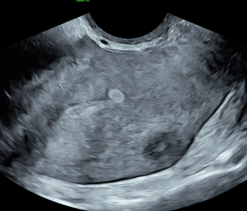

Globular/heterogeneous
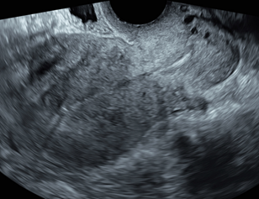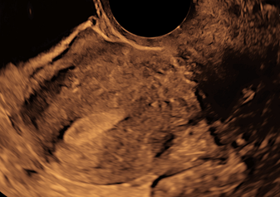
Asymmetrical myometrial thickening
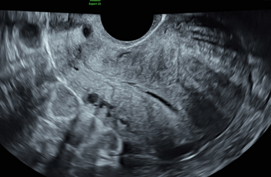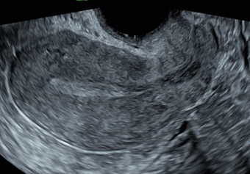
Subendometrial cysts w/ translesional vascularity
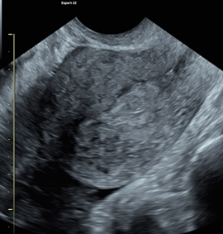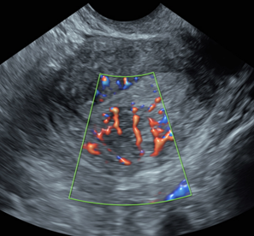

Subendometrial cysts
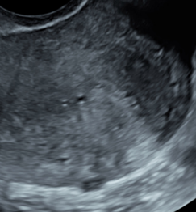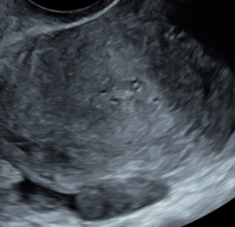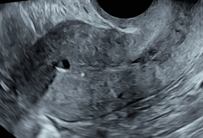
Irregular junctional zone Interrupted junctional zone
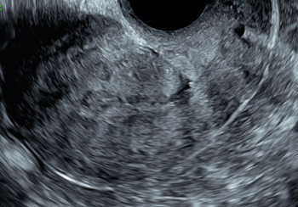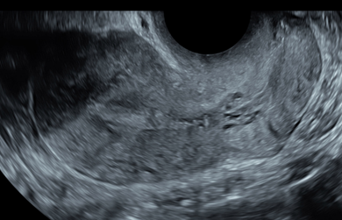
Heterogeneous/fan-shape shadowing/globular/echogenic subendometrial lines & buds/interrupted junctional zone
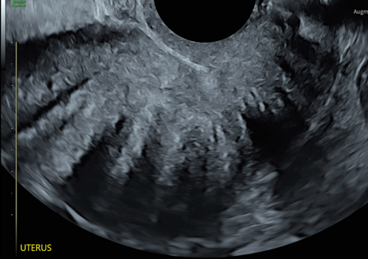

SIS: Workflows/Tray Setup & Supplies/Documentation
- Consent Forms: prepared by MA team when requested
- Allergies: Ask about Iodine allergy. If the patient is allergic to Iodine then use the Hibiclens instead.
- Pain Management: Occasionally, some patients will ask for Ibuprofen after the SIS procedure to take before they leave our office. If the patient requests pain management post procedure, communicate this to the provider involved. Nitrous may be offered in some WHA locations for pain management.

- Timing of the procedure: The optimal timing for a SIS procedure to be performed is between days 7-10 of the cycle.
  - If there is a concern with LMP date and a concern about a possible pregnancy discuss this with the provider before the procedure is performed. Pregnancy tests are required (unless the patient refuses) prior to SIS procedures and the provider MA who is performing the procedure can document the test result. (see flow chart below)
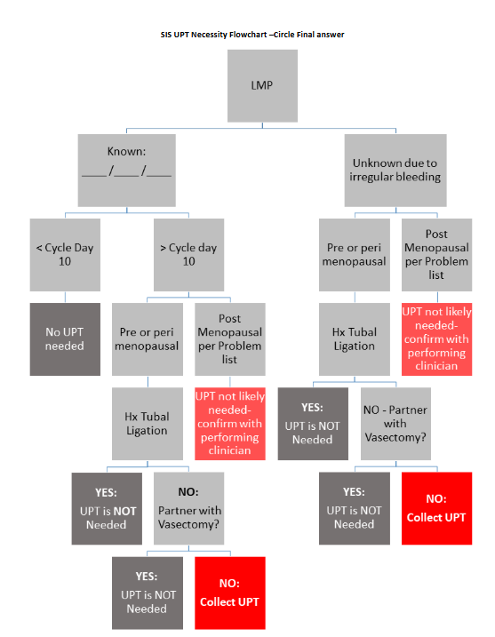

- Supplies needed:
  - Open sided (side arm) speculum (Graves & Pederson)- leave packaged for provider to select appropriate speculum
  - Mayo stand- place the following instruments & supplies on a sterile drape:
-Autoclaved SIS instrument package: Tenaculum, Curved Kelly, Ring Forceps, Sound, Cup for iodine/hibiclens
-Scopettes (x6)
-Catheter (if balloon catheter, fill the 3cc syringe with 1.5cc of saline fluid)- test balloon
-Sterile plastic dilators (x3)
-20 cc syringe- fill with sterile saline fluid- flush catheter
-surgilube
-Iodine/Hibiclens (check for allergies)- place in cup
  - Sterile Saline on hand
  - Sterile gloves- provider
  - Chux pads under the patient and on the floor at base of bed
  - Gooseneck lamp w/ disposable sheath
  - Stool
  - Prepped transvaginal probe w/ cover
  - Stool
  - Consent Form (MA provides)
  - *be prepared with a formalin bottle, extra label and pipette curette if provider wants to perform an endometrial biopsy
- Tip: One saline solution bottle can be used for multiple SIS procedures in the same day if there has been no cross contamination between patients. Discard the saline solution at the end of the day or after the procedure.
- Tray set up:
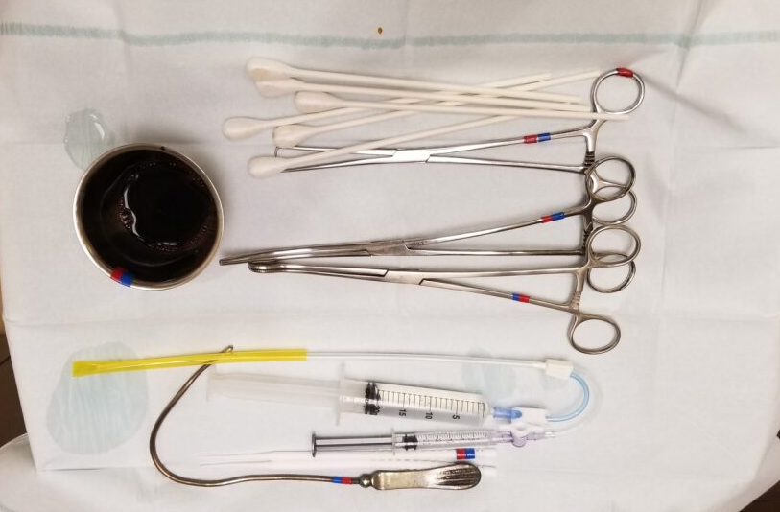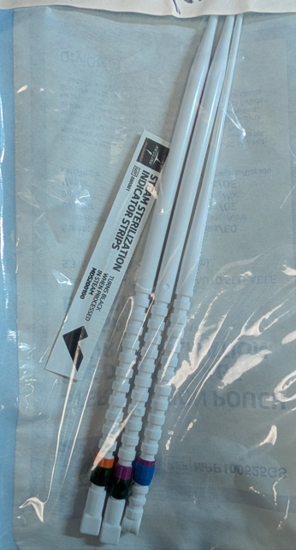
SIS Documentation (CPT 76831)
Please refer to the scanning protocol above

GYN Ultrasound Guided Procedure:
IUD insertion/removal OR Endometrial Biopsy (CPT 76998):
- Consent Forms: prepared by MA team when requested
- Allergies: Ask about Iodine allergy. If the patient is allergic to Iodine then use the Hibiclens instead.
- Pain Management: Occasionally, some patients will ask for Ibuprofen after the procedure to take before they leave our office. If the patient requests pain management post procedure, communicate this to the provider involved. Nitrous may be offered in some WHA locations for pain management.
- Provider’s MA prepares tray with instruments and supplies
- Have available: sterile gloves, gooseneck lamp, stool, iodine/hibiclins, speculum options, chux pads, pantyliners
- Scanning Protocol:
- Procedural documentation:
Please refer to the scanning protocol above

Incidental Findings
How we define an incidental finding outside the scope of OB/GYN:
- Patient with suspected mass/lesion identified outside the scope of OB/GYN imaging: bowel, kidney, liver, peritoneal cavity
- Patient with suspected renal anomaly or any other urinary tract finding

How to document: When an incidental finding outside the scope of OB/GYN is identified by the sonographer, document the finding in 2 orthogonal planes, utilize color Doppler and measure.

How to report incidental findings:
- OB report-
  - maternal structures>third tab over>select the appropriate drop-down option, include measurements
  - Dropdown impression comment>incidental finding
    - f/u during pregnancy
    - f/u post-partum
- GYN report-
  - Add ‘findings’ field to the report from the form content tab – 
  - Select the appropriate drop-down option, include measurements
  - Dropdown impression comment>incidental finding

Common Scenario Workflow
What is this Adnexal Finding in a Pregnant Patient Who Has an IUP?
- EPIC order/Viewpoint exam remains an OB
- MFM reaches out to GYN reader by phone to review images
- If GYN reader is unavailable, the MFM will request USC’s assistance > USC will communicate in teams channel and connect any available GYN reader with an MFM.
- MFM will finalize the exam after reviewing with the GYN reader; GYN readers name will be entered into the impression section of the report as a secondary reader/reviewer.
Viewpoint Title: GYN Reader
Comment: "The exam included findings which were reviewed with the GYN ultrasound reader, Dr. X. "

Is it an OB or GYN Ultrasound? Patient Presents with +HCG with NO IUP (includes suspected ectopic pregnancies and early pregnancies with bleeding)
- *Should be ordered as an OB
- Keep EPIC order and Viewpoint exam an OB
- Sonographer > keep patient in room or clinic until further instruction is provided by MFM
- MFM reaches out to GYN reader by phone to review images
- If GYN reader is unavailable, the MFM will request USC’s assistance > USC will communicate in teams channel and connect any available GYN reader with an MFM.
- MFM will provide instructions to the sonographer for patient plan.
- MFM will finalize the exam after reviewing with the GYN reader; GYN readers name will be entered into the impression section of the report as a secondary reader/reviewer.

Evaluate for RPOC (known prior pregnancy loss or status post-delivery)
- *Should be ordered as a GYN
- Keep EPIC order and Viewpoint exam a GYN
- In the presence of RPOC and a stable patient, no acute symptoms from the patient, sonographer may release the patient and communicate findings via teams IM to the GYN reader of the day.
- In the setting of acute symptoms, keep patient in the room and have the USC team reach out to GYN reader STAT for guidance.
- GYN reader finalizes the report and communicates appropriately with the ordering provider.

How to Change Exam Type/EPIC Order/Requested Procedure in VP

  - Exit the viewpoint exam
  - In EPIC, go to your tech work list
  - Select “verify orders”
  - Select applicable order> “change order” 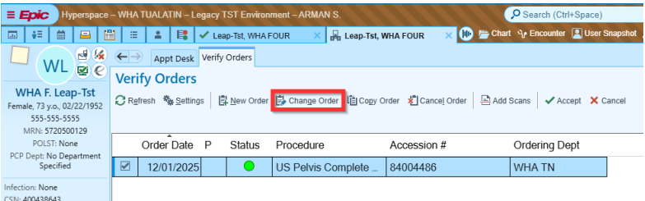
  - Change the procedure to the applicable order
  - Enter any other applicable fields
  - Select “accept” 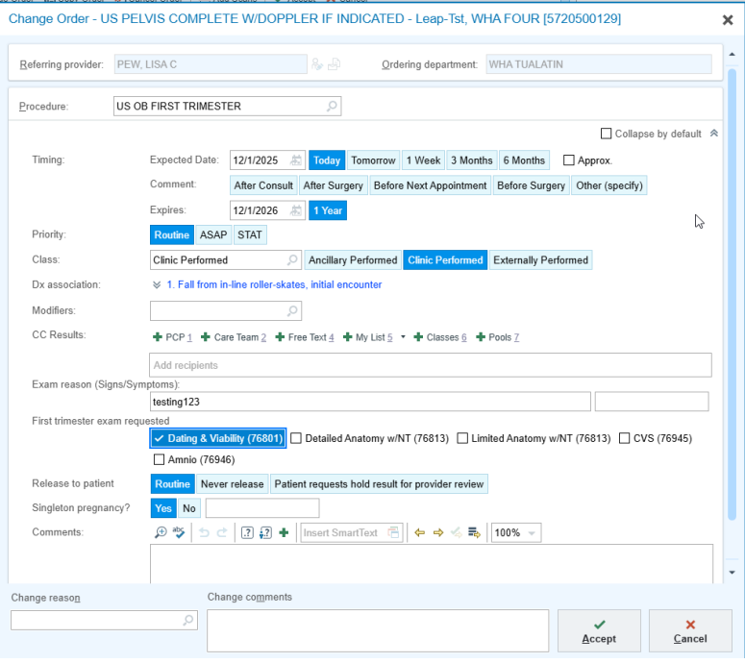
  - Click “OK” to continue with the order change 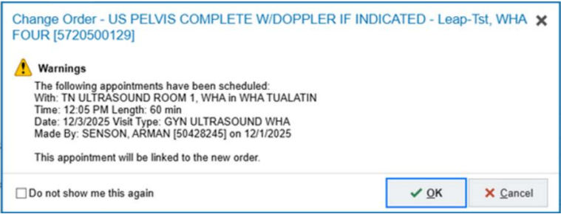
  - Ordering provider & authorizing providers should automatically be filled in already
  - Select “Signed Paper/Fax Order – Scanned” from the order mode dropdown list 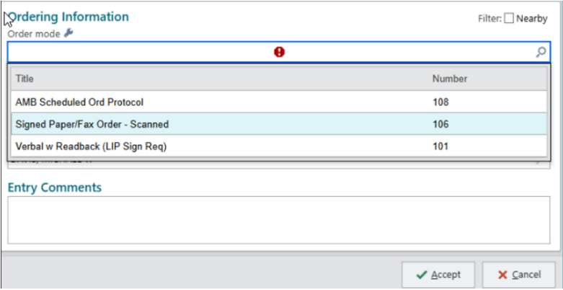
  - Select “Accept” 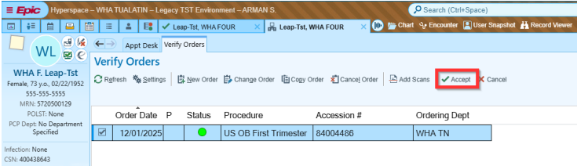
  - Open the viewpoint report> click on the requested procedures tab>confirm the order has updated 